**Sopna** 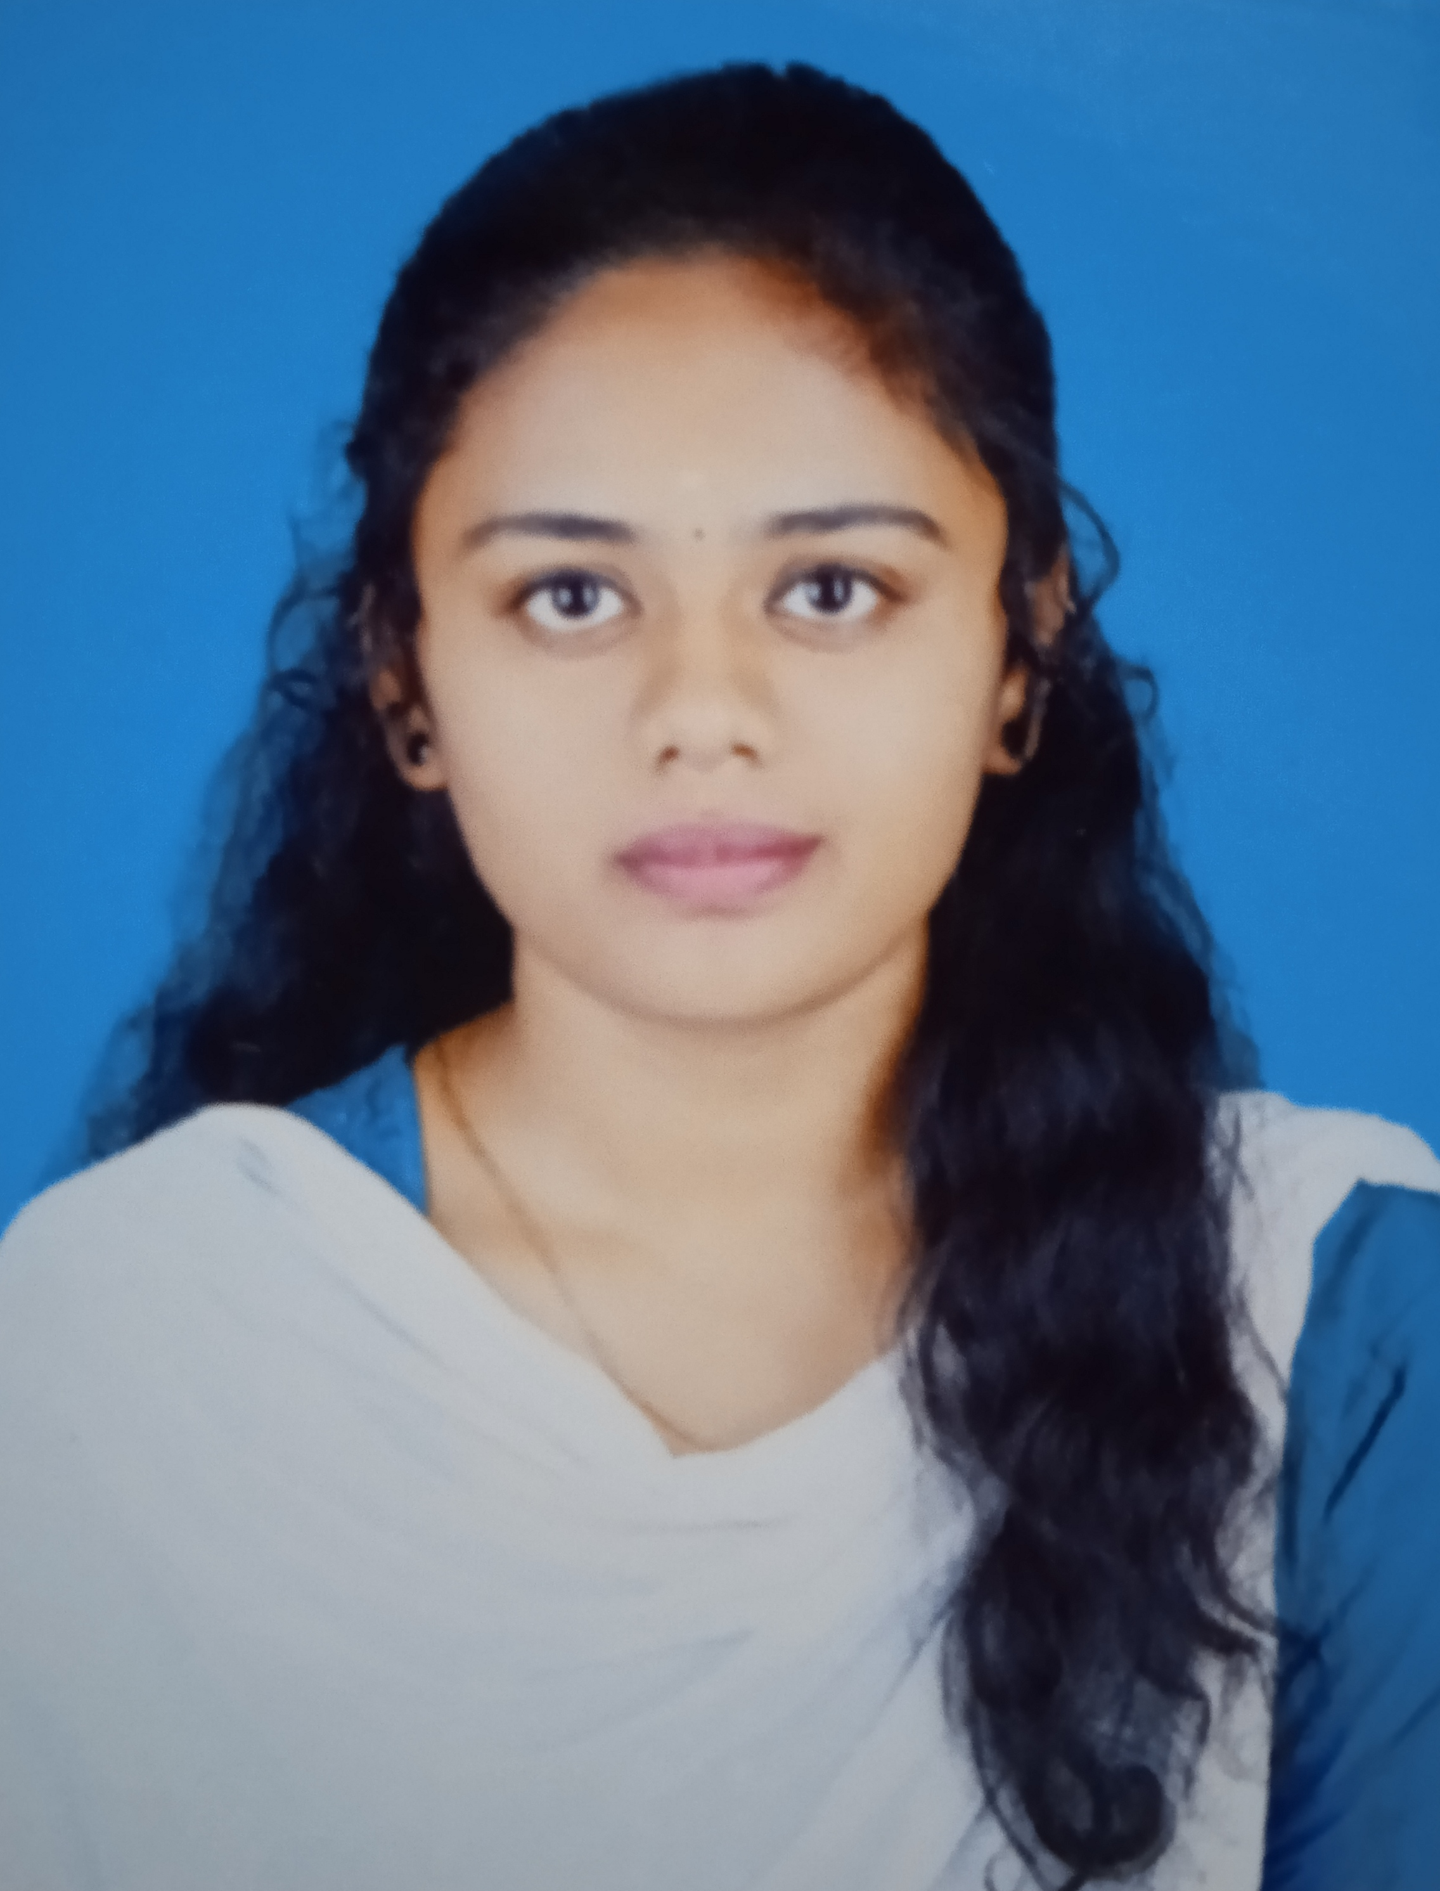

Tenkasi,Tamilnadu,627811

+91 9786920614

[sopnaparamasivan@gmail.com](mailto:sopnaparamasivan@gmail.com)

**CAREER OBJECTIVES:**

Motivated and enthusiastic individual seeking a challenging Position as freshers to utilize and enhance my skills in [IT].I am Eager to contribute to a dynamic term and gain practical experience in A professional environment.

**EDUCATION:**

|  |  |  |  |
| --- | --- | --- | --- |
| **Degree** | **Institutions** | **Year of passing** | **Percentage** |
| x | Mkv kandasamy nadar matric hr sec school tenkasi | 2019 | 77% |
| xii | Tmt manjammal govt girls hr sec school tenkasi | 2021 | 87% |
| Bsc cs | Einstein college of arts and science seethaparpanallur | 2024 | 7.66% |

**TECHINICAL QUALIFICATION:**

* C
* Java
* Python
* Html

**SKILLS:**

* Strong communication and interpersonal skill
* Proficient in [c,java,python]
* Ability to work effectively both independently and as part of a team
* Quick learner with a strong work ethic
* Time management

**LEADERSHIPS AND INVOLVEMENT:**

I have participated in state level spellbee international competieion.And I have participated in symposium which is conducted in other colleges.

**LANGUAGES KNOWN:**

* Tamil
* Malayalam
* English